|  |
| --- |
| **A. Project Information** |

**Student(s):**

1. Haziq Iskandar Bin Suriani 1628259
2. Ahmad Zulfahmi Bin Harum 1626867

**Project ID:**

412D

**Project Title:**

Note Assist

**Project Category:**

Development

**Supervisor:**

Dr. Suriani bt. Sulaiman

|  |
| --- |
| **B. Introduction** |

**Project Overview**

This system is based on voice recognition. The way its work is by capturing the lecturer’s speech during the class into text. This to ensure that there are no points missing during the lectures given. The language barrier issue between students and lecturers are common in a campus as we know the environment of study in IIUM consist of foreign lecturers and foreign students too, this software can help in settling issue by giving the speech-to-text for both parties to understand. The captured speech later can be generated into note points format(s). Importantly, the app targets to assist the student in their study.

**Problem Statement**

Note has been a crucial component in learning, organizing and keeping track of it may be a fussy task to the students and accessibility are sometimes limited to the learners especially to persons with disabilities.

In a big lecture hall that occupied with at least 50 students, focusing on the lecture might be challenging as we assumed that the lecturer is not using a microphone. This can be related during the time of our study, we often see students easily distracted as they can not give their full attention.

The problems are identified as follows:

* Students can not hear a clear explanation and understanding due to the less language fluency from the students itself.
* The language barrier between students and lecturers can happen as IIUM community occupied with students and lecturers from other countries.
* Jotting down notes while the lecturer is giving lesson is not effective as this divided attention can lead to missing important points and loss focus.

**Project Objective**

This project aimed to :

1. Provide a cloud-based note taking platform that can be accessed

by users anywhere and anytime.

2. Create a semi-automated jotting platform that enables users

to organize and have controls over their notes.

3. Provide an automated summarization of notes recorded in

class in the form of speech to text.

4. Assist the note taking process by people with disabilities such

as deaf, mute and dyslexic.

**Significance of Project**

The targeted users is the students and the teachers. It is useful to break the language barriers between the two parties; students and teachers, through the multilanguage based platform. Moreover, it is more efficient in helping students to focus on the teaching lessons than dividing their concentrations to two different tasks; focusing on the lessons and jotting notes. This enable students to give their thorough concentration to comprehend the teaching. Hence, they will not miss any of the important points in the teachers lesson sessions. Furthermore, this project also targeted specifically students with disabilities such as deaf people may have problem on hearing the speeches, an automated speech engine will help them to capture the words by teachers. Hence, this project might be a game changer to a group of people that need special attention like them. In addition, the software can be used in any corporation that held a conference meeting to also break the language barriers through the translator features in the software.

**Project Schedule**

* **Final Year Project 1 Gantt Chart**

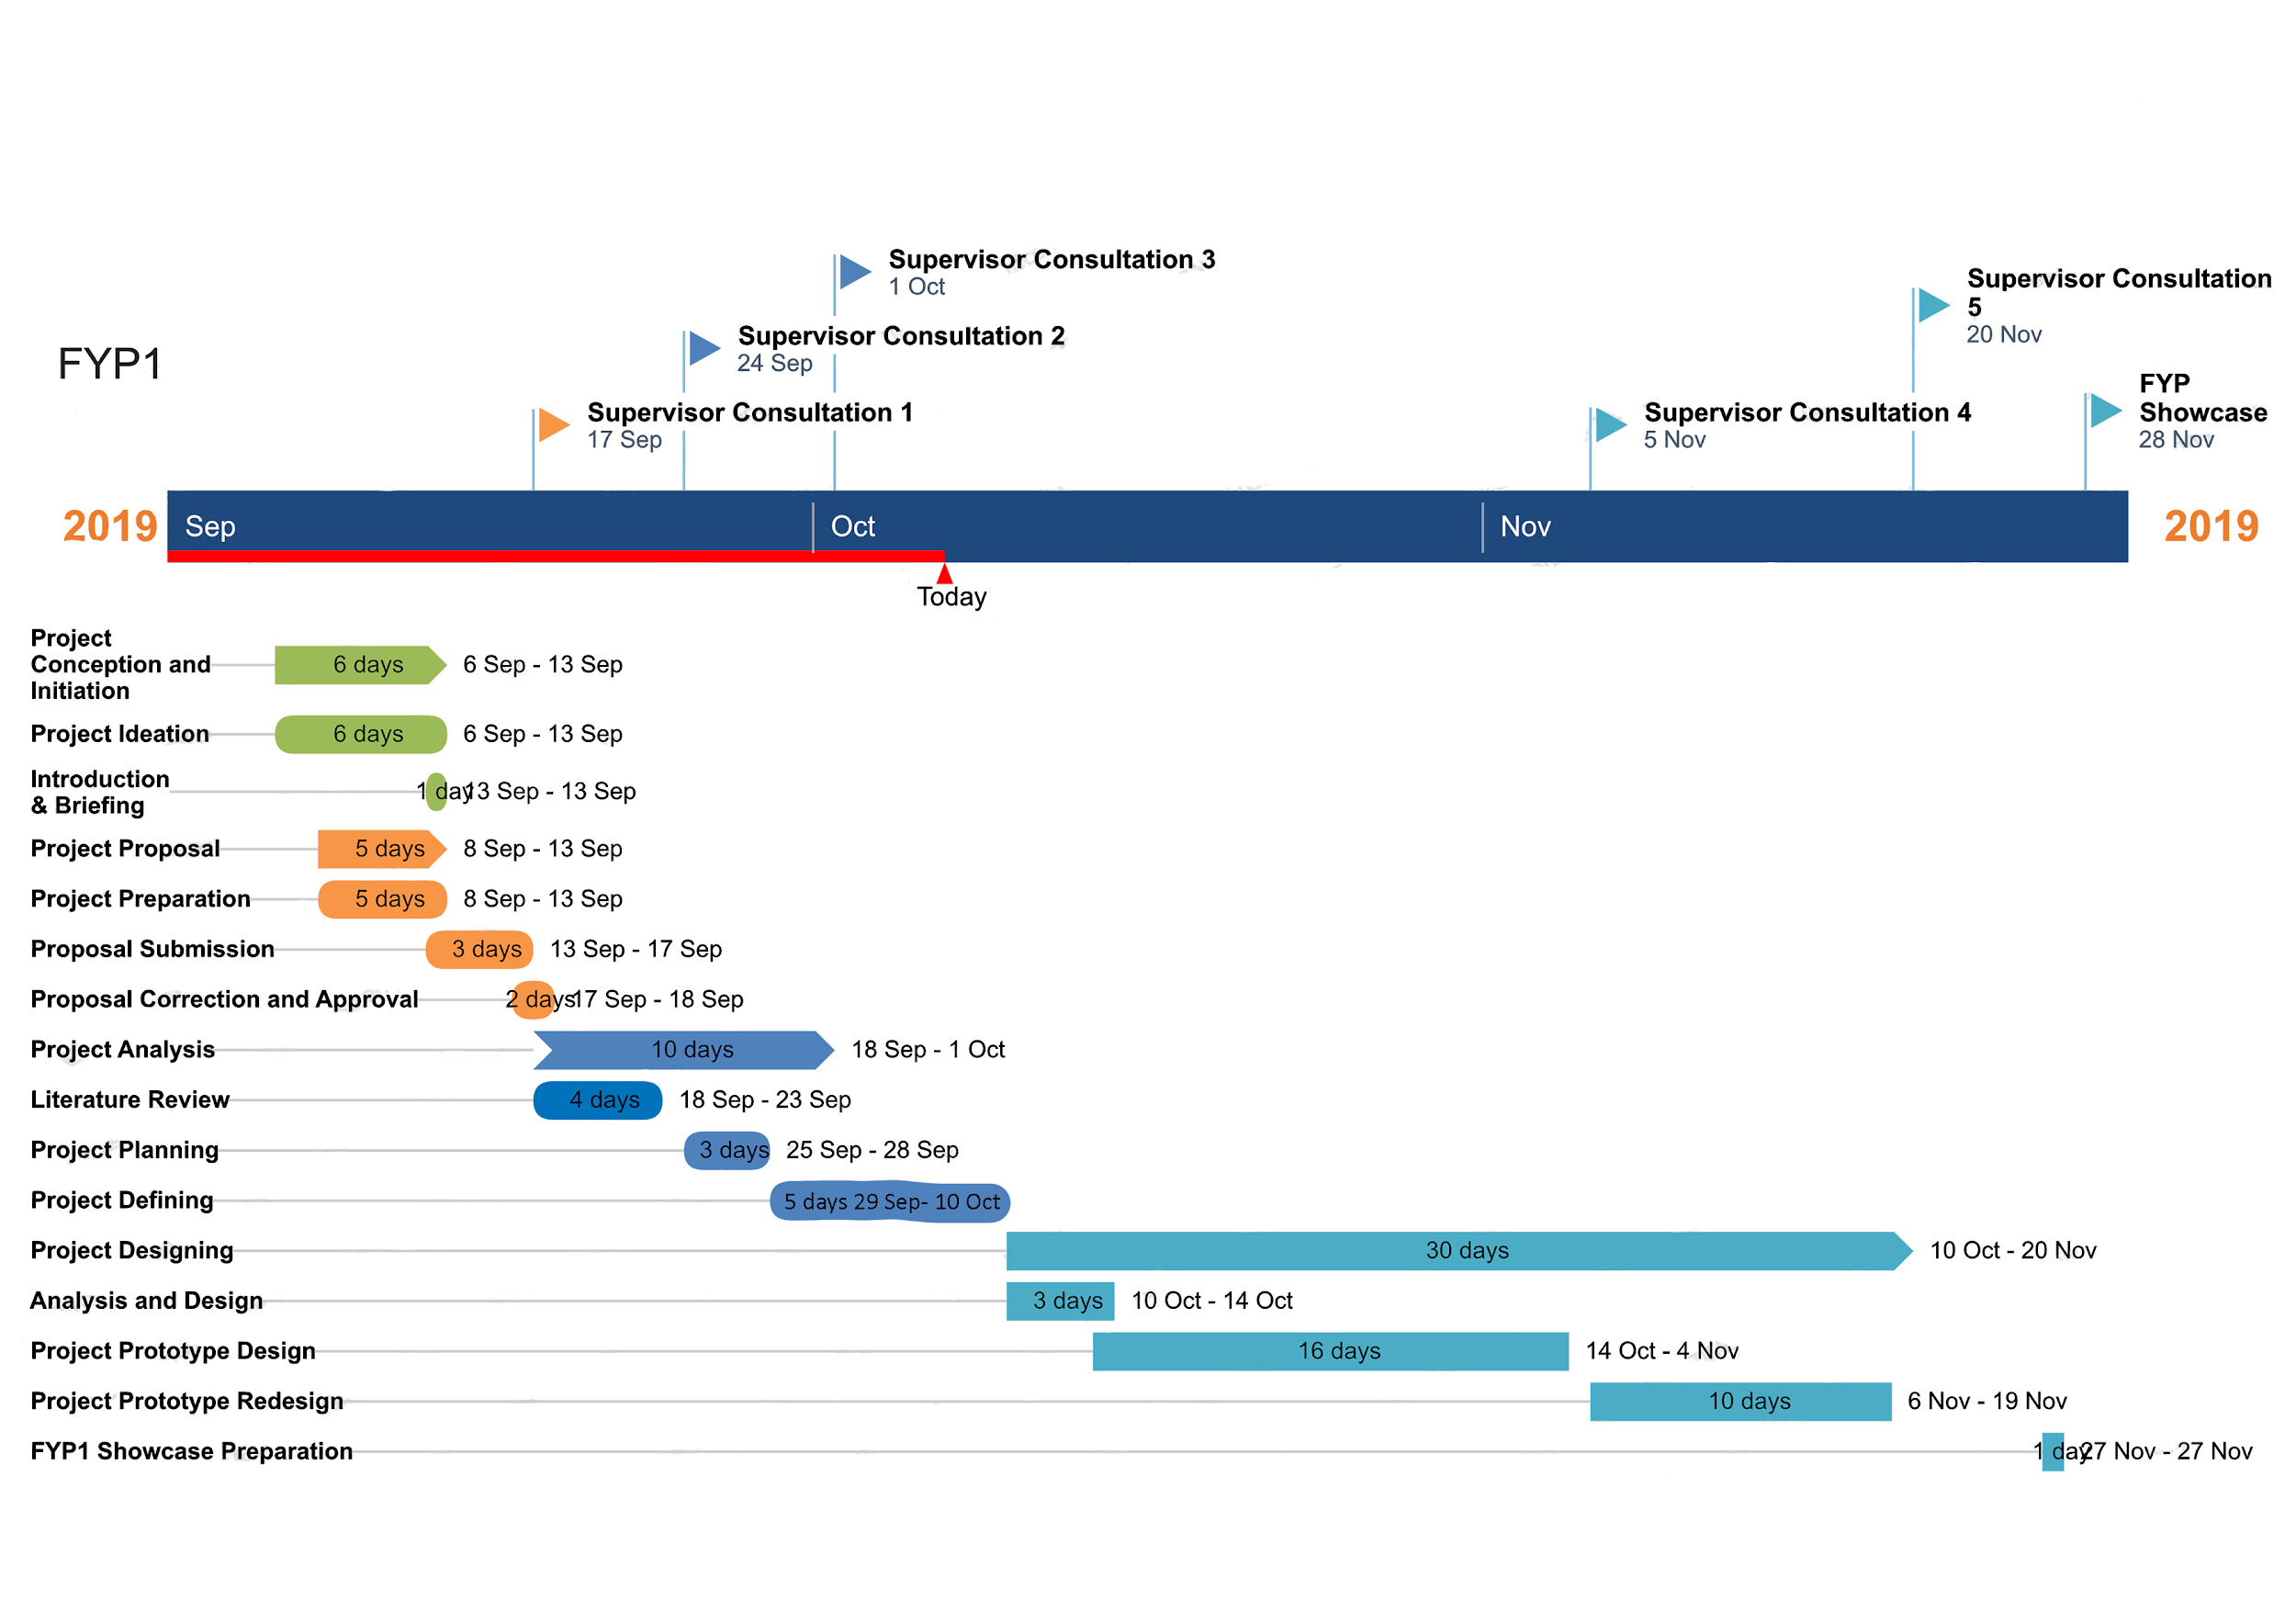

* **Final Year Project 2 Gantt Chart**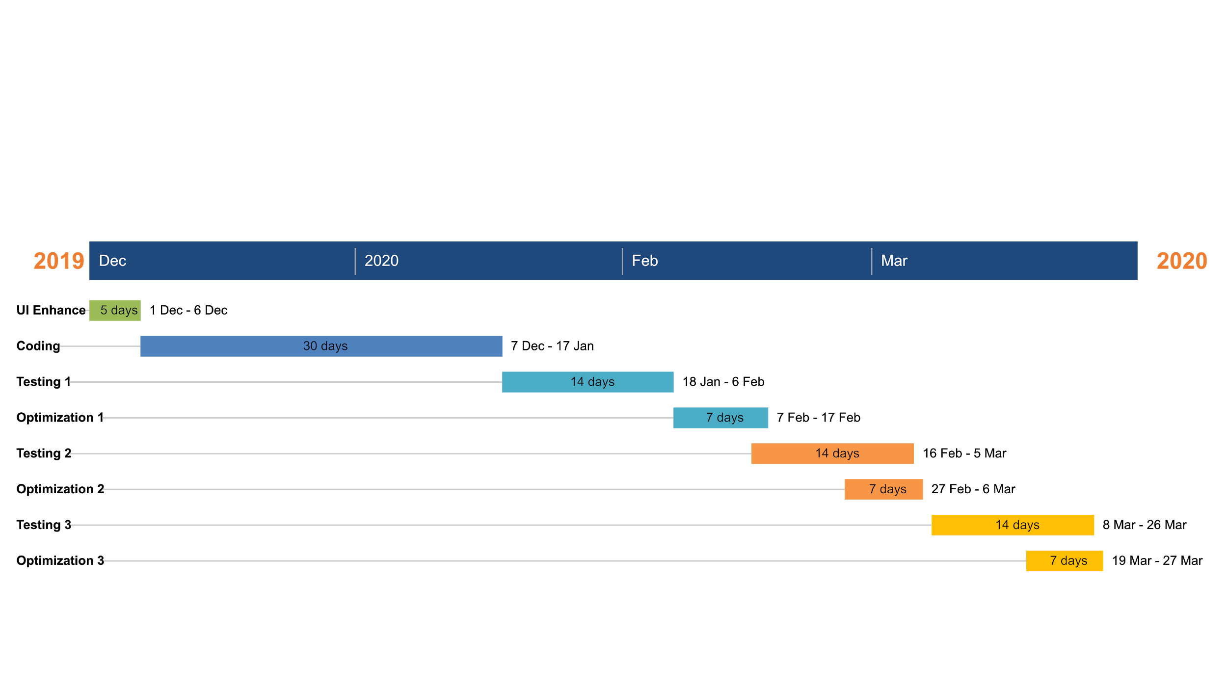

|  |
| --- |
| **C. Review of Previous Work** |

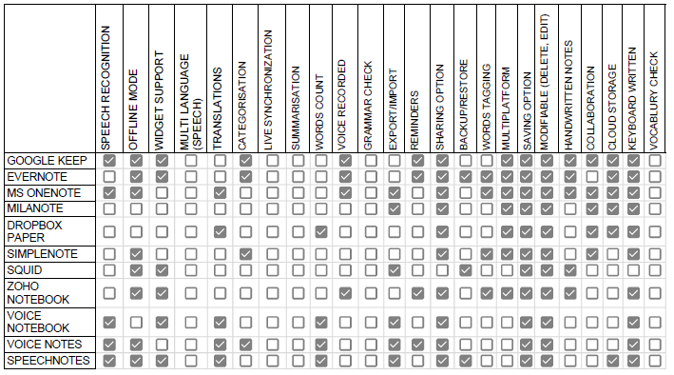

For literature review, a study on the similar applications, which implicate application that has the same characteristics as Note Assist. A total of eleven applications has been studied to acquire the requirements for this project including ; Google Keep, Evernote, Microsoft Onenote, Milanote, Dropbox Paper, Simplenote, Squid, Zoho Notebook, Voice Notebook, Voice Notes and Speechnotes., has been used for reference for development process for Note Assist Application. Features studied has been done through the software matrices, refer to appendix, to differentiate the features of which most applications has and has not.

The best three applications derived from this study are Google Keep, Evernote and Voice Notes.

1. **Google Keep**

A note-taking service developed by Google that is available on the [web](https://en.wikipedia.org/wiki/Web_application), and mobile [apps](https://en.wikipedia.org/wiki/Mobile_app) for the Android and iOS mobile operating systems.It offers a variety of tools for taking notes, including text, lists, images, and audio. Users can set reminders, which are integrated with Google Now. It is cloud-based service that will be synchronized all through the cloud in many platforms attached to an account. Belows are few depictions of Google Keep:

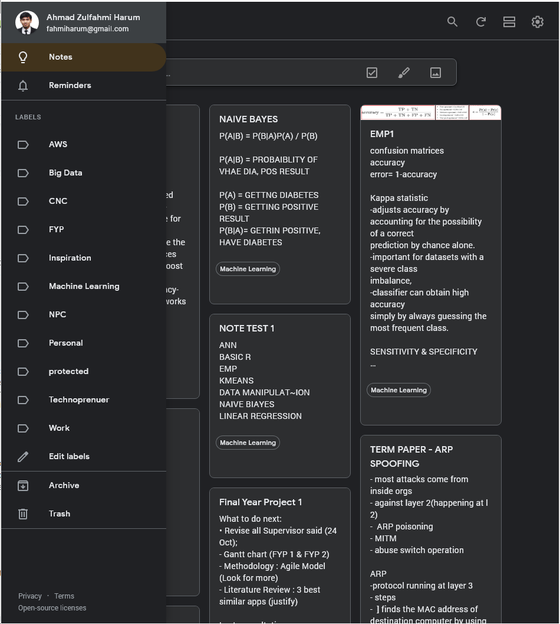

Figure B.1.1 shows the desktop version of Google Keep. Google Keep also has introduced a dark mode features to give an eye relief to the user compared to the light mode that may harm the user’s eyes after a long day of staring at the electronic lights. It is convenient for user to straight away type in their notes to Keep as it keeps the jotting platform at a place that is easy to find. After that, users can add labels to the notes that are taking whenever they want. Regardless, before, in the middle or after taking down the note.

In the jot taking of Keep desktop, users can include several types of note; word, picture and writing. But in the mobile platform, Figure B.1.2., they enhanced several features in it due to sophisticated devices that led to a variety of data input. 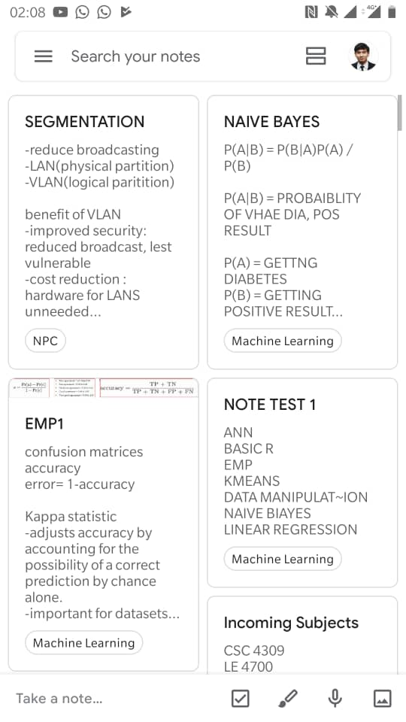

The advantages of using Keep as your daily note driver is it synchronized in a personalized Google account. Which is the main company for mobile, email, search engines and services, makes it accessible anywhere and fully utilized in an operating system developed by Google; Android.

The backdraw of using the Keep, it is less organized compared to other note taker. The only mechanism that segregate the section is only singular labeling. User might find it hard to search through the date or any other segregating elements. luckily , they have the search panel for user to look for keyword.

Keep might have been one of the best note drivers and is the software that is used as a reference model. Keep does not have the features to be synchronous in a real time and simplifying note. That is one of the features that will be proposed to the note assist.

1. **Evernote**

Evernote is an app designed for notetaking, organizing, task management, and archiving.It is developed by the Evernote Corporation. The app allows users to create notes, which can be text, drawings, photographs, or saved web content. Notes are stored in notebooks and can be tagged, annotated, edited, searched, given attachments, and exported. It is cross-platform, for Android, [iOS](https://en.wikipedia.org/wiki/IOS), macOS, and Microsoft Windows. It is free to use with monthly usage limits, and offers paid plans for expanded or lifted limits.

The great features for this app is clipper from website. Meaning, any useful article user found on the website can be clipped into Evernote and read later in offline mode. In addition, the interface of Evernote either in mobile or computer application are neat and simple. The word tagging are very useful features in helping keeping notes organized.

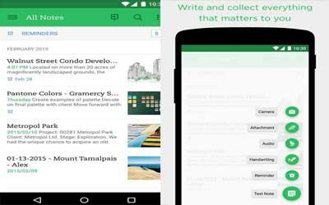

Figure B2.1 : Mobile version

The disadvantages of Evernote is the desktop version does not contain any feature for password to keep the notes from strangers but can use in mobile phone. Other than that, there is no speech recognition in this apps. If this feature exists, this app will be very flexible and give freedom for users to use the notes

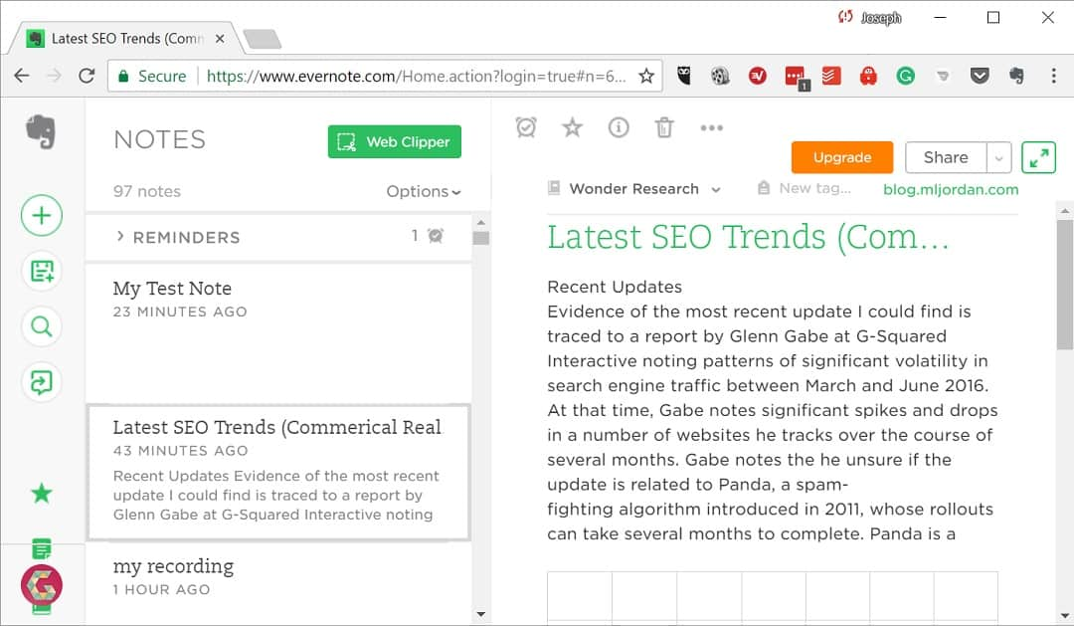

Figure B2.2: Desktop version

1. **Voice Notes**

Voice Notes by Gawk is a note-taking app with voice recognition where your speech converts to text with one touch only. It can remind you later at the time you set where it integrated with calendars in your phone. Like others, it automatically save notes into your storage files and easy backup to cloud.

There are few advantages of Voice Notes; the interface of Voice Notes is easy to access and minimal. When we need to create a note, just click the create button and it will automatically start to detect your voice. This apps also allow user to set reminder after creating the note. For example, “Feed cat” and there will be calender button to choose the date and time. Besides, the note created can be categorised accordingly. Voice Notes got the feature to export/import files which were able to save the files outside the apps or do backup. Below are the screenshot of the apps;

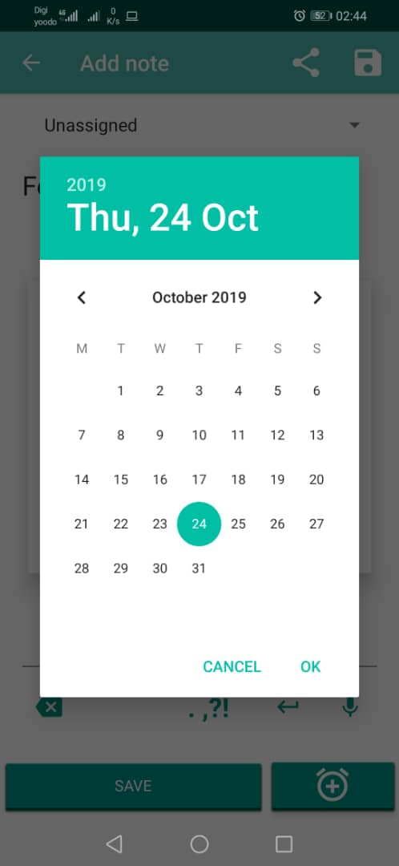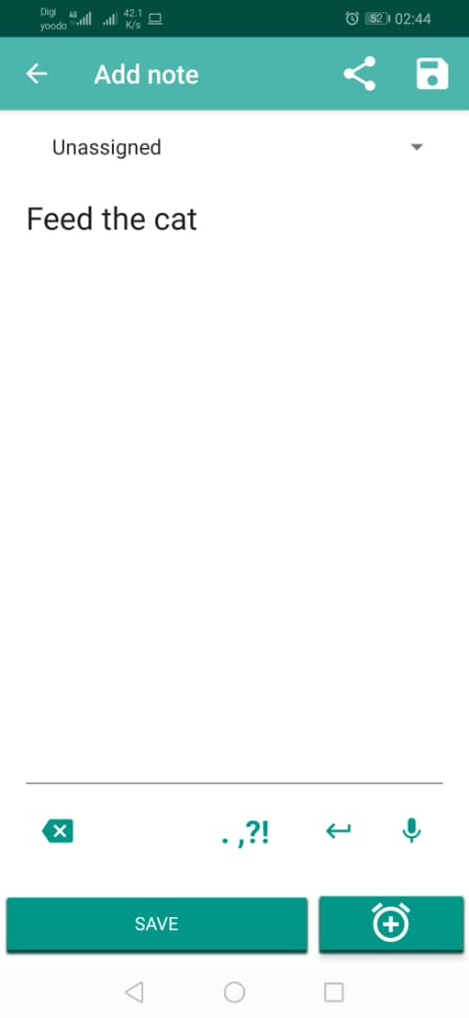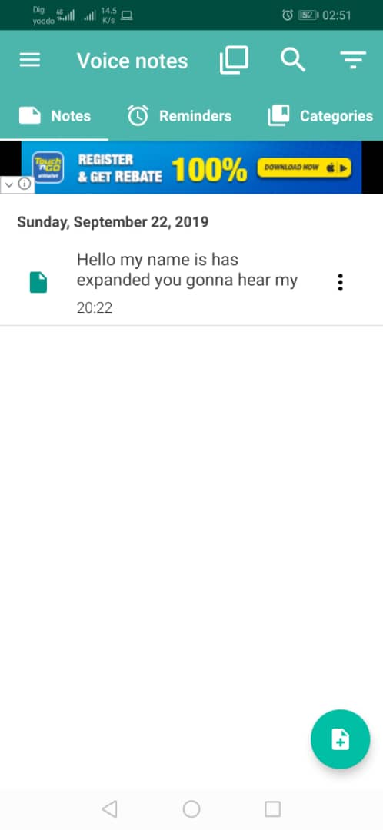

Figure B.3.1 : Screenshots of Voice Notes

The drawback of this apps is there is no automatically backup to cloud. Other than that, Voice Notes does not has a multiplatform such as web-based for user to access in any devices.

These applications have features that will ease the adaption of the note taking process.Furthermore, the features are;

1. Voice Note

An audio recording feature that will enable users to capture an audio and store it the application for reference purposes.

2. Speech Recognition

Converting speech to text features that has the ability to capture audio and process it to text. This feature is one that will eliminate the process of note taking through user interactions.

3. Categorisation

The ability to categorise notes according to its subject from the study of the content of the note and suggesting user to label the note under the keyword.

These features are found in the best three applications mentioned. This literature also has produced another output, three most applications has that are crucial for note-taking adaptation are;

1. Sharing

Such feature is produced to enable user to collaborating with related parties to has an updated content of the note subject. It has saved time for delegating tasks through the net rather than the conventional meeting to combine every part from each party.

1. Offline mode

Most of the applications are available without the internet connectivity which enable users to store the notes even when there is internet connectivity problem.

1. Multi-platform

Feature that enables users to access in any platform that are available at the moment; website, through the laptops or personal computers, and mobile applications.

This project also aimed to produce a text summarization features. Few studies on the related algorithm has been done to optimize the algorithm for the mentioned feature.

Thus, all these three apps got their own pros and cons. The pros of these apps can be implemented in the system adaptation in our project while the cons of each app can be overcome by our upcoming software; Note Assist. The next feature can be added is text summarisation and grammar checker.

**References**

1. Bijl, D., & Hyde-Thomson, H. (2001). *U.S. Patent No. 6,173,259*. Washington, DC: U.S. Patent and Trademark Office.
2. Furui, S., Kikuchi, T., Shinnaka, Y., & Hori, C. (2004). Speech-to-text and speech-to-speech summarization of spontaneous speech. *IEEE Transactions on Speech and Audio Processing*, *12*(4), 401-408.
3. Jing, Hongyan. “Sentence Reduction for Automatic Text Summarization.” Proceedings of the Sixth Conference on Applied Natural Language Processing -, 2000, doi:10.3115/974147.974190.
4. Stinson, M. S., Elliot, L. B., Kelly, R. R., & Liu, Y. (2009). Deaf and hard-of-hearing students' memory of lectures with speech-to-text and interpreting/note taking services. *The Journal of Special Education*, *43*(1), 52-64.

|  |
| --- |
| **D. Methodology** |

For this project, the methodology used is Agile Model. This approach helps in software development where there will produce ongoing release cycles. Agile is a developing cycle that enable developers to update the development as the requirement changes. Suits for this project that the requirement may change from time to time. Below are the diagram of agile model.

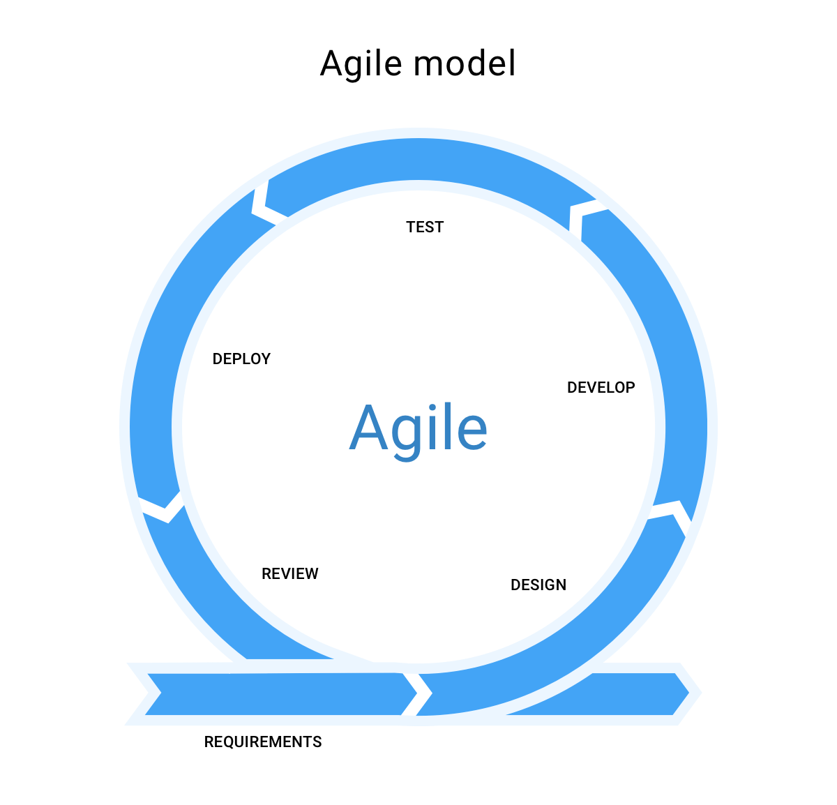

The methodology applied to this project is Agile system development cycle. Agile is put to frame as it is a cycle that focus on the customer collaboration. Note Assist is a product that is used for many of human interactions; speaker and audience, teachers and students or boss and secretary. Optimization of Note Assist need the review in the customer perspective in every single feature that are available in application.

Starting from requirements stages, this project has collected the requirements and discover insight of the project. Later, based on the acquired requirements , the designing process started. In this stage, the elements used in the development of this system drivers will be decided at this stage; what framework, database and user interface.

Then comes developing stages, the design that are fabricated in the designing stages will be put to work here. Series of debugging to uncover the bugs and fixing it. In testing stage, few tests will be run to the application, usability testing, UX testing and such. This is to discover inconvenience and element that disturbs the features.

Deploy stage, once the application is ready for end users, it will be deployed to testers and open its access to special end-users segments. In the last stage, reviews are acquired through the UX testing in the previous stage. All discovered facts, knowledge or note to improve the application will be brought to the initial stage, Requirement stage, and the process is started from the initial until the outcomes of the project satisfies all user requirements.

In Conclusion, Agile is very flexible in adapting changes to the applications. Thats is the factor it is suitable for Note Assist developmentation. From time to time, functionalities can be implemented stage by stage. Through this, a note taking application that meets all user requirements.

|  |
| --- |
| **E. Progress** |

1. **Algorithm**

For the auto-summarization part, the algorithm used is text summarization. The text summarization has two types; extractive text summarization and abstractive text summarization.

Extractive Text Summarization rely on extracting several parts from the text such as sentences, words and phrases. Later, stack these parts together to create a summary.

Abstractive Text Summarization is more advance in NLP which this algorithm generate an entirely new summary and differ from the original text. It uses the encoder-decoder method.

For this project, Note Assist will be using the Extractive Text Summarization algorithm because it is more reliable and effective in extracting sentences and phrases from the piece of text. The specific algorithm for this extractive text summarization is called TextRank algorithm. Using the TextRank algorithm, the summary can be reduced into specify percent of reduction.

Below are flow of the TextRank algorithm:

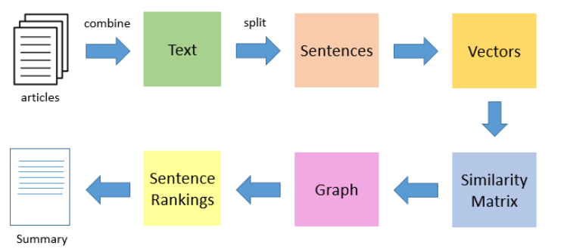

Figure 7.1 Flow of TextRank Algorithm

Flow details of TextRank Algorithm:

1. Concatenate all the text contained in the speech-to-text.
2. Split the text into individual sentences.
3. Find vector representation for each and every sentence
4. Similarities between sentence vectors are then calculated and stored in a matrix.
5. Sentences as vertices and similarity score as edges are then converted into a graph for sentence rank calculation.
6. A certain number of top-ranked sentences from the final summary.

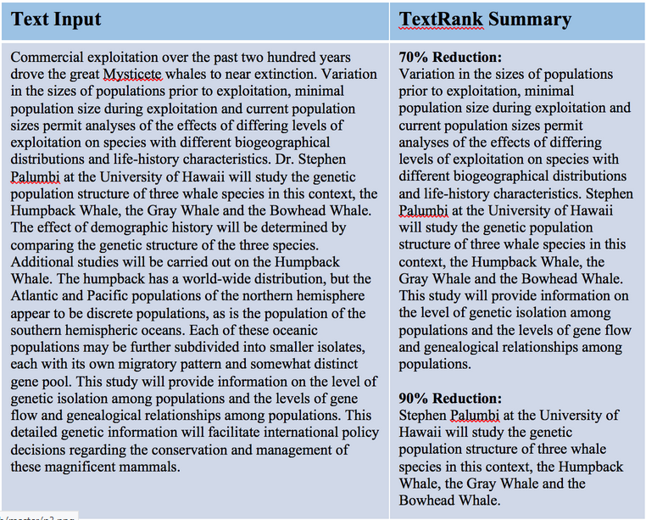

Figure 7.2 TextRank summary example

On Figure 7.2 depicts an example of the text input with its summarization. This summary is based on the TextRank algorithm with 70% reduction and 90% reduction. Importantly, it summarizes the relevant information.

For the auto-identify important point uses the same algorithm, TextRank algorithm to extract common word occured and giving option for the users to just filtering the sentences based on the common words (important points).

**(2) Prototype**

The prototype application used for the building of Note Assist Prototype is Adobe XD. This prototype is built to comprehend and ease the user adaptations to the applications. It depicts the actual interface of Note Assist web application.

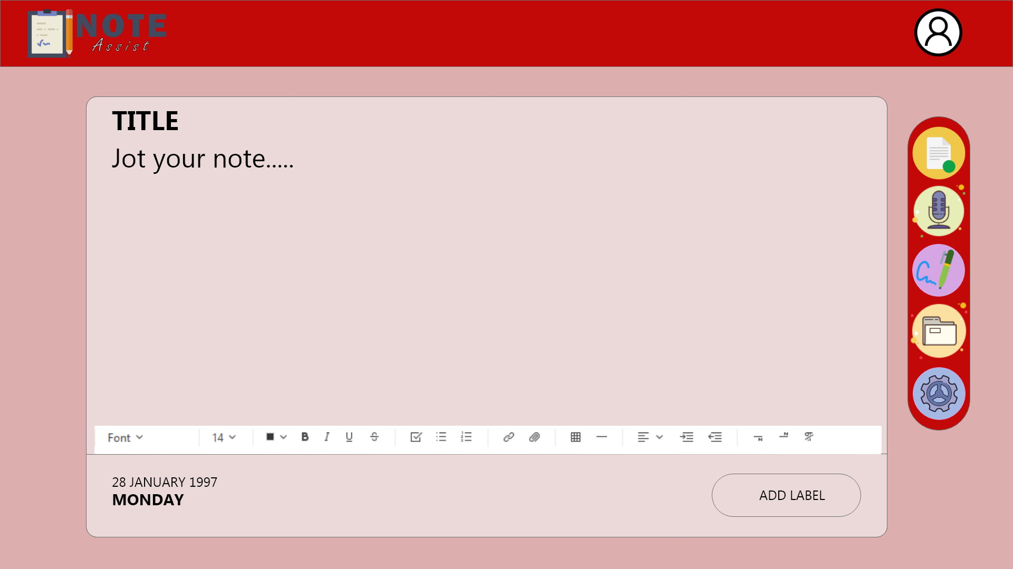

Figure 9.1

Figure 9.1 is the actual depiction of home page for Note Assist. In this page, user can jot down all the notes without having any interruptions. However, to access all features, like saving the notes and converting speech notes to text, users will need to logon to the web applications. Next is Voice Note (figure 9.2) and Handwritten Note (figure 9.3) pages.

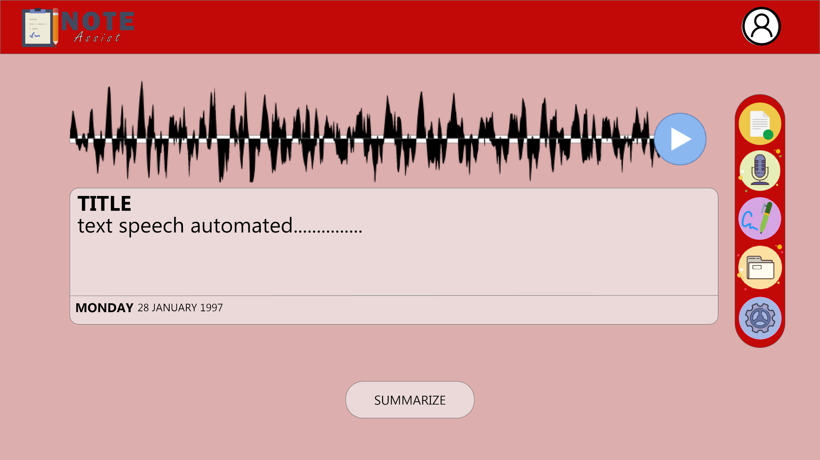

Figure 9.2

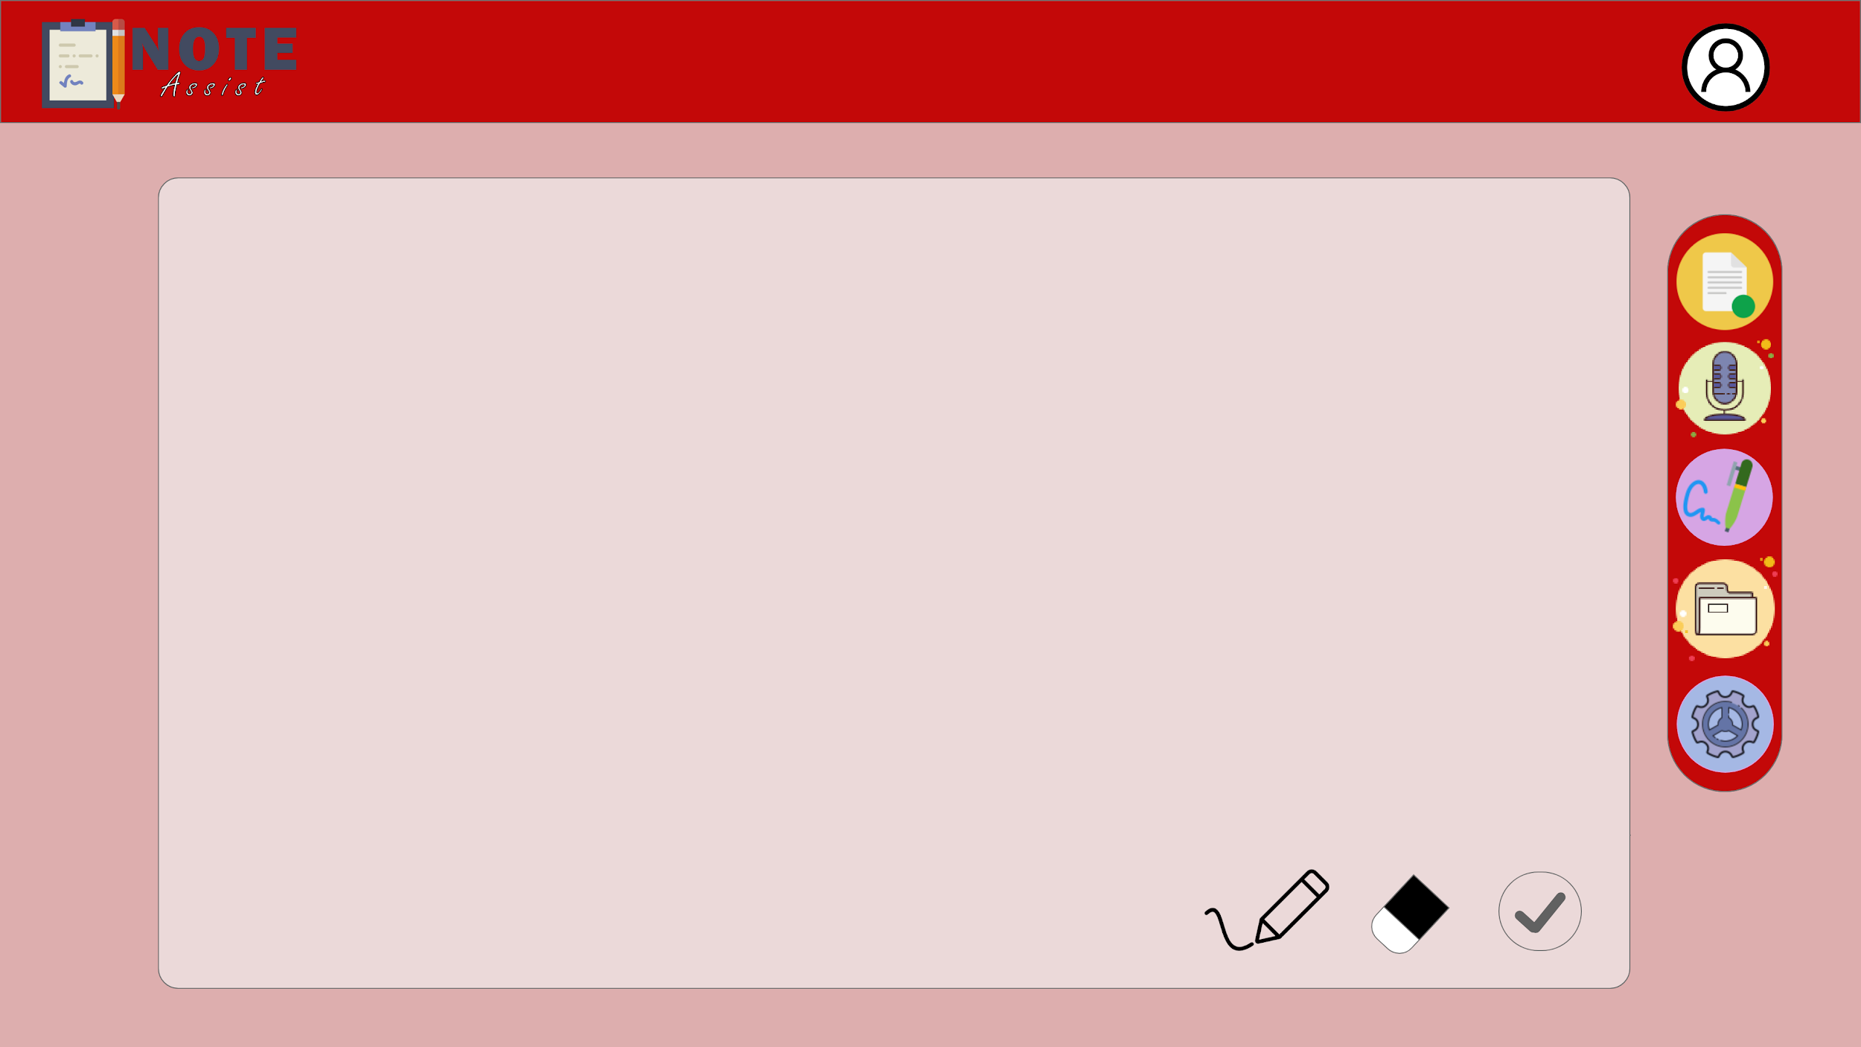

Figure 9.3

Both of these pages, are enabling users to take note using various channels. There are three methods in total; audio, handwritten and typing. These features can be accessed through the page from Homepage (Figure 9.1), Speechnote page (Figure 9.2) and Handwritten page (Figure 9.3). Speech notes have another feature that enables the web application to summarize the speech from the recorded audio.

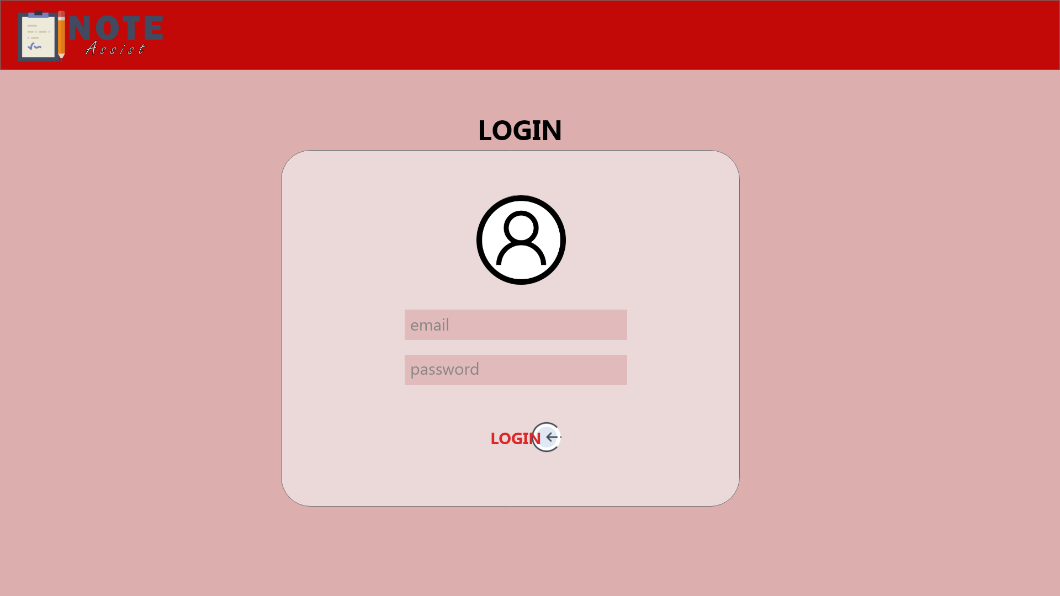

Figure 9.4

Login page (figure 9.5) is the authentication that is used to synchronize the data to an account linked to the registered email. All note that jotted in the web application will be saved to a storage that is linked under the account.

The next two pages are where to access saved notes. Both play the same role as they organize the saved notes. It differentiated in terms of view; List-view(Figure 9.5) or Box-view(Figure 9.6).

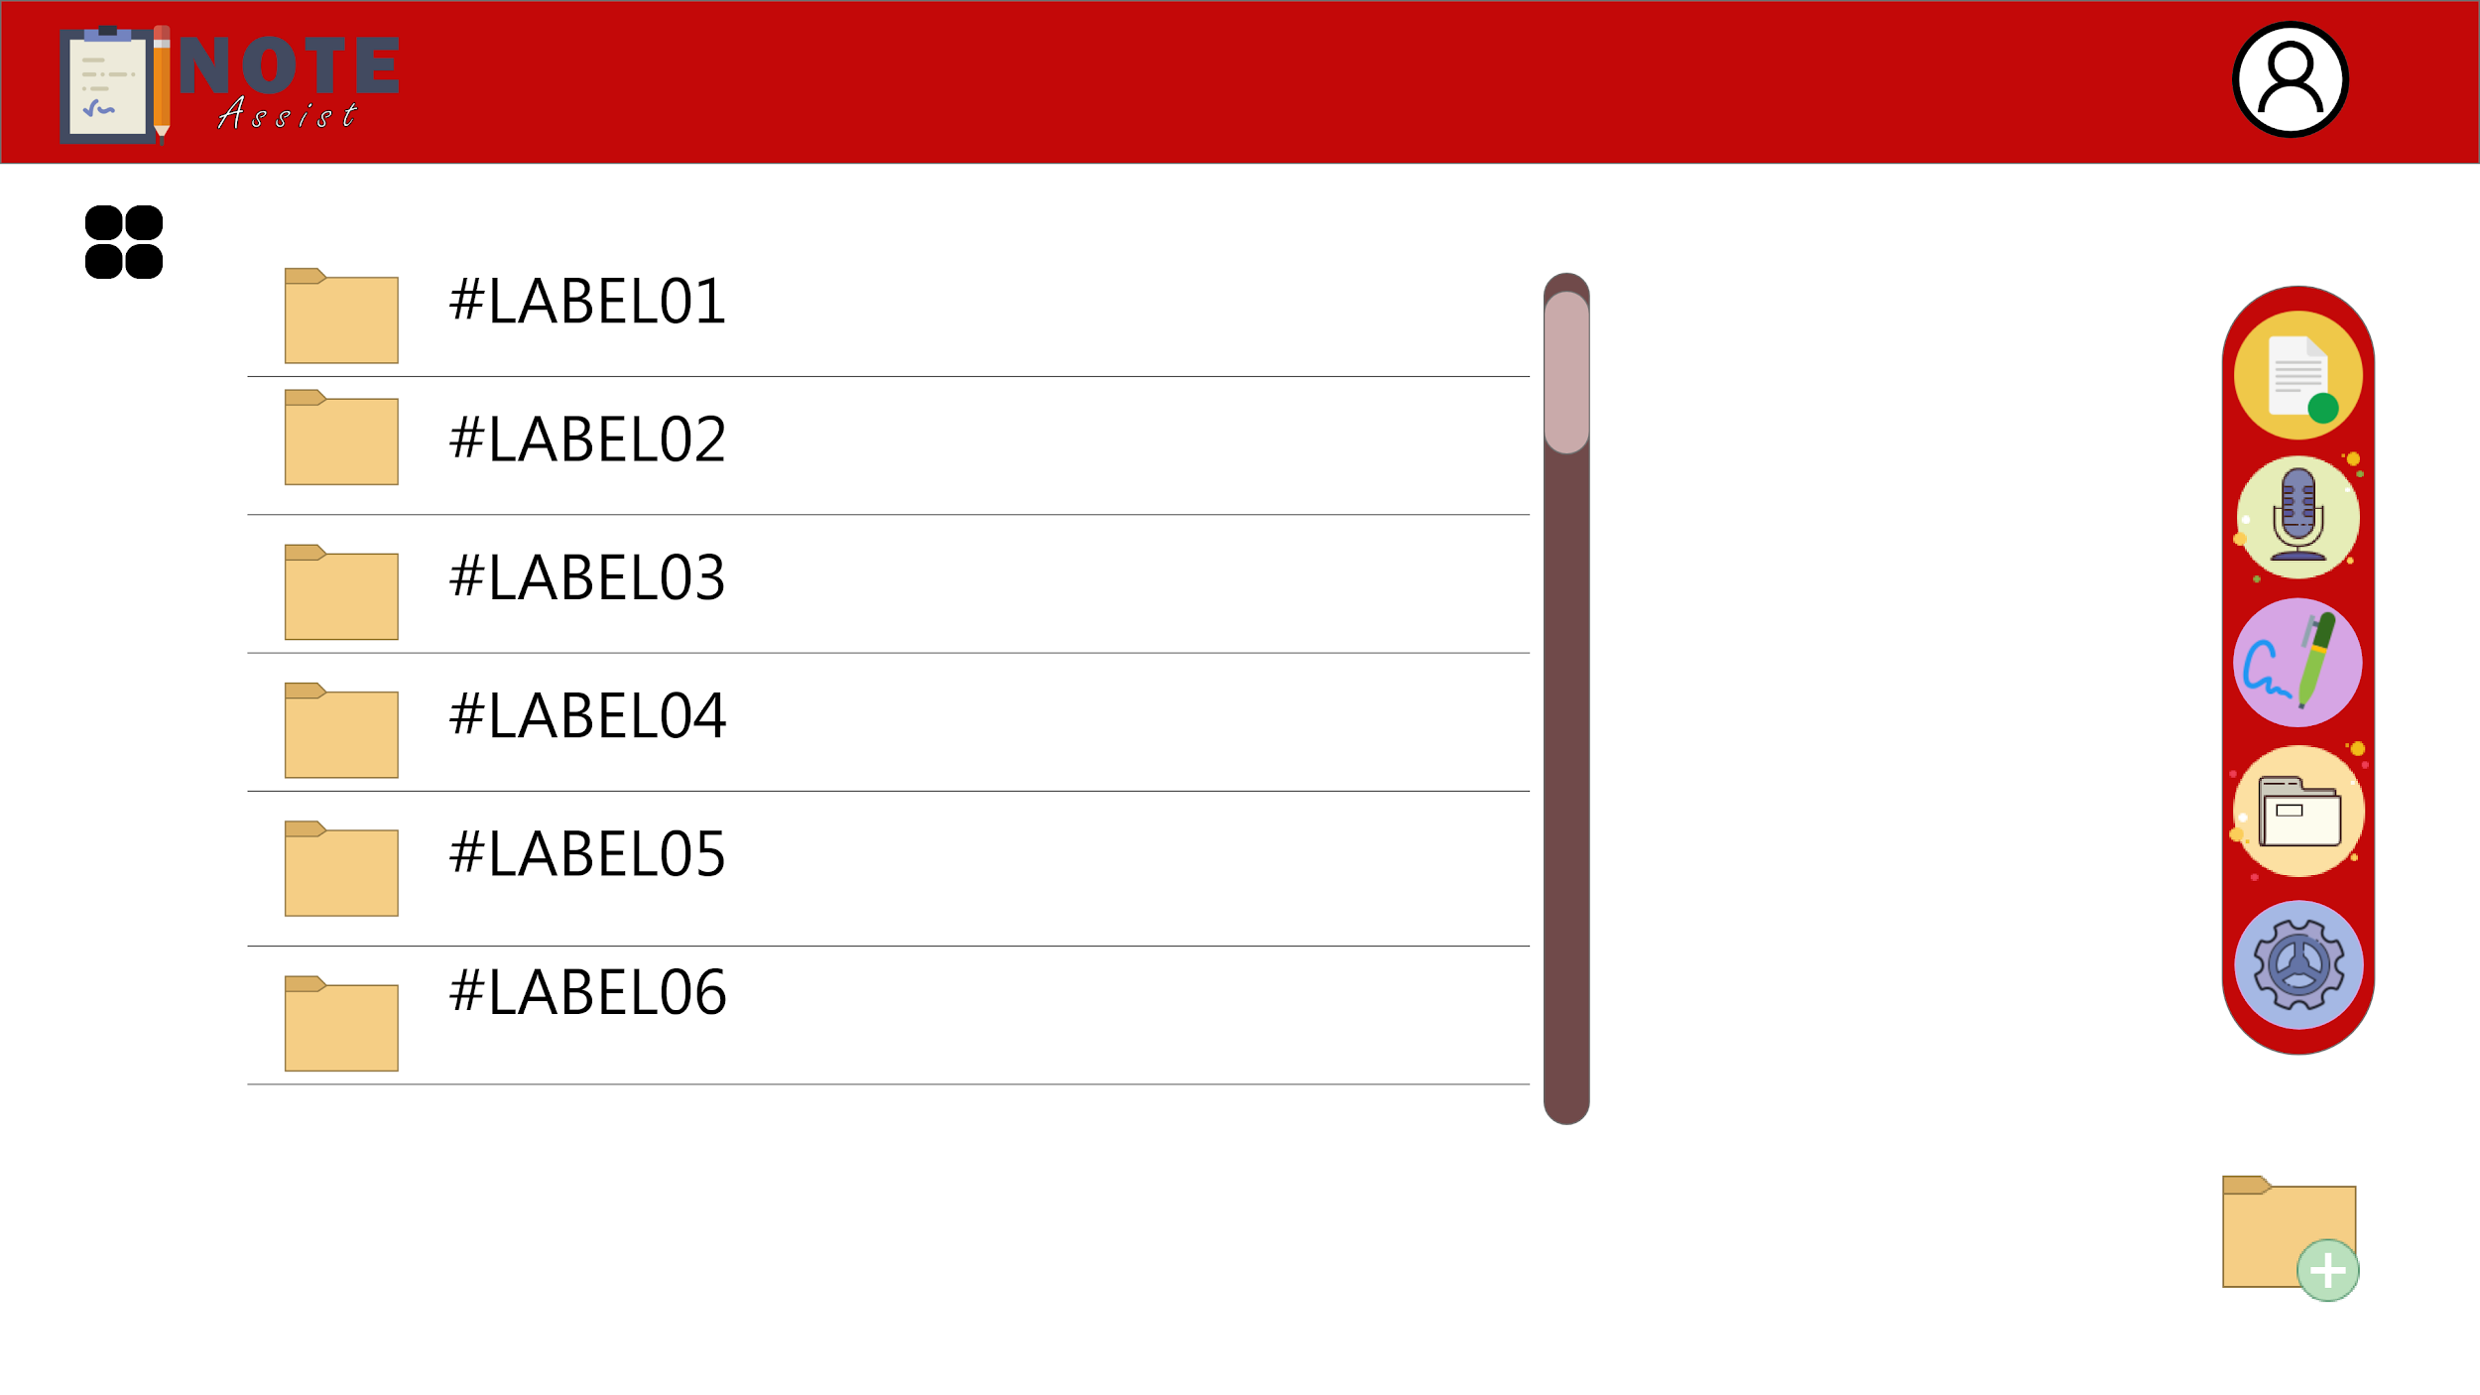

Figure 9.5 : List-view

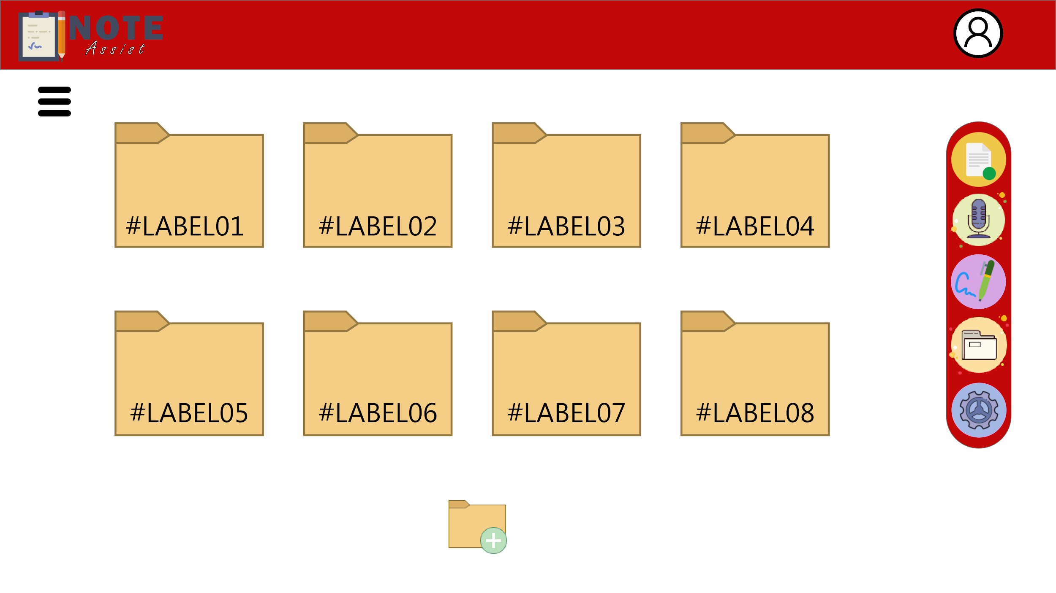

Figure 9.6 : Box-view

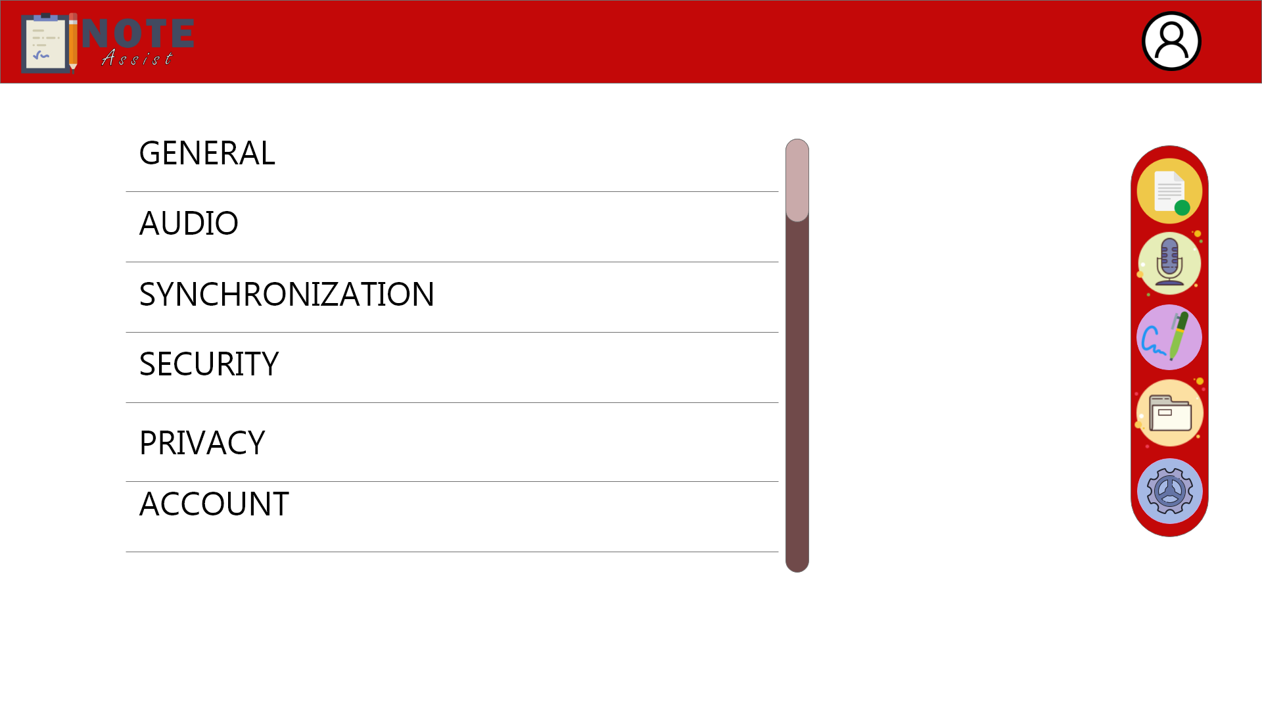

Figure 9.7

In figure 9.7, this is the setting page to let the users have the control over their preferences. There are few categorisations; General, Audio, Synchronization, Security & Privacy and Account. Users can maneuver the settings to have a daily note driver comprehends to their preferences.